
Week 1 Practical Tutorial
Building the Freeman Industries Virtual Lab
VMware Workstation Pro | Portfolio folders | Initial requirements analysis
Unit | J27P 35 - Server Administration for Cyber Security
SCQF level | 8
Scenario | Freeman Industries Secure Infrastructure Project
Scenario contact | David Freeman, IT Manager
Assessment link | Week 1 tutorial upload
SQA criteria | O1.1 and O3.5
Suggested duration | Approximately 2.5 to 3.5 hours
What you will produce
By the end of this tutorial you will have a clearly organised project folder structure, an isolated VMware network, three empty virtual-machine shells, an initial requirements register and the evidence needed to complete the Week 1 Moodle upload.

1. Tutorial purpose and learning objectives
This tutorial launches the practical Freeman Industries project. You are not installing Windows Server during Week 1. Instead, you will prepare the virtual laboratory and evidence structure that will be used throughout the 22-week unit. This week’s completed tutorial must include evidence of the lab and folder structure, at least five organisational requirements, and an explanation of how evidence will be stored securely.
After completing the tutorial, you should be able to:
- Create a structured and maintainable set of portfolio and virtual-lab folders.
- Explain why the practical work must be kept inside an isolated virtual environment.
- Configure a VMware host-only network without connecting the lab directly to the college production network.
- Create correctly named virtual-machine shells for a server, a Server Core installation and a client computer.
- Identify business and security requirements from the Freeman Industries scenario.
- Plan evidence storage that avoids passwords, keys, personal information and uncontrolled copies.
- Capture and explain evidence rather than relying on screenshots alone.

Important assessment principle
Screenshots alone are not sufficient. Each screenshot, diagram, configuration record or test result must be explained in your own words. Your explanation should state what the evidence shows and why it proves that the activity was completed.

2. Safety, ethics and lab rules
- Complete all practical work inside the approved virtual lab. Do not scan, test or reconfigure the college production network.
- Use only fictional users, test files and fictional company information.
- Never place passwords, private keys, recovery keys or other live secrets in screenshots, documents or recordings.
- Do not use Bridged networking unless your lecturer gives explicit permission for a specific activity.
- Record significant changes and keep evidence organised so that another administrator could understand what was done.
- Treat the virtual environment as though it contained real business systems.

3. Before you begin
You will need the following:
- A Windows computer with VMware Workstation Pro installed.
- Permission to use the computer for virtualisation and enough free disk space for the planned virtual machines.
- The Freeman Industries Scenario Brief, Integrated Portfolio Assessment Brief and Week 01 Tutorial.
- A personal SSD with sufficient free space for the virtual machines, ISO files, snapshots, exports and backups. Virtual-machine files must not be stored on the local drive of a college computer..
- Windows Server 2025 and Windows 11 installation media supplied or approved by your lecturer. The ISO files are not used to install the operating systems until a later tutorial.

3.1 Check that hardware virtualisation is available
1. Press Ctrl + Shift + Esc to open Task Manager.
2. Select Performance and then CPU.
3. Check the Virtualisation entry. It should show Enabled.
4. If it shows Disabled, stop and inform your lecturer. Do not change BIOS or UEFI settings on a college computer unless authorised.
Evidence capture point
Capture a screenshot showing that virtualisation is enabled.

3.2 Check host resources
Before allocating resources to virtual machines, record the host computer's installed memory, processor and available disk space. Do not allocate all host resources to the lab. The host operating system must remain responsive.
Host resource | Value recorded by learner | Planning note
Installed RAM | [Enter value] | Keep enough RAM free for the host operating system.
Processor / logical processors | [Enter value] | The suggested VMs use two virtual CPU cores each.
Free disk space | [Enter value] | Allow space for VMDK files, snapshots and exports. This should be on your SSD
Project storage location | [Enter path] | Use your personal SSD. Do not store any VMDK, snapshots or exports onto the college computer.

4. Task 1 - Create the project folder structure
Create one top-level folder for the entire unit. Keep portfolio evidence separate from large virtual-machine files. This makes the evidence easier to back up and prevents accidental attempts to upload virtual disks to Moodle.
Example top-level folder name:
Server_Administration_J27P35
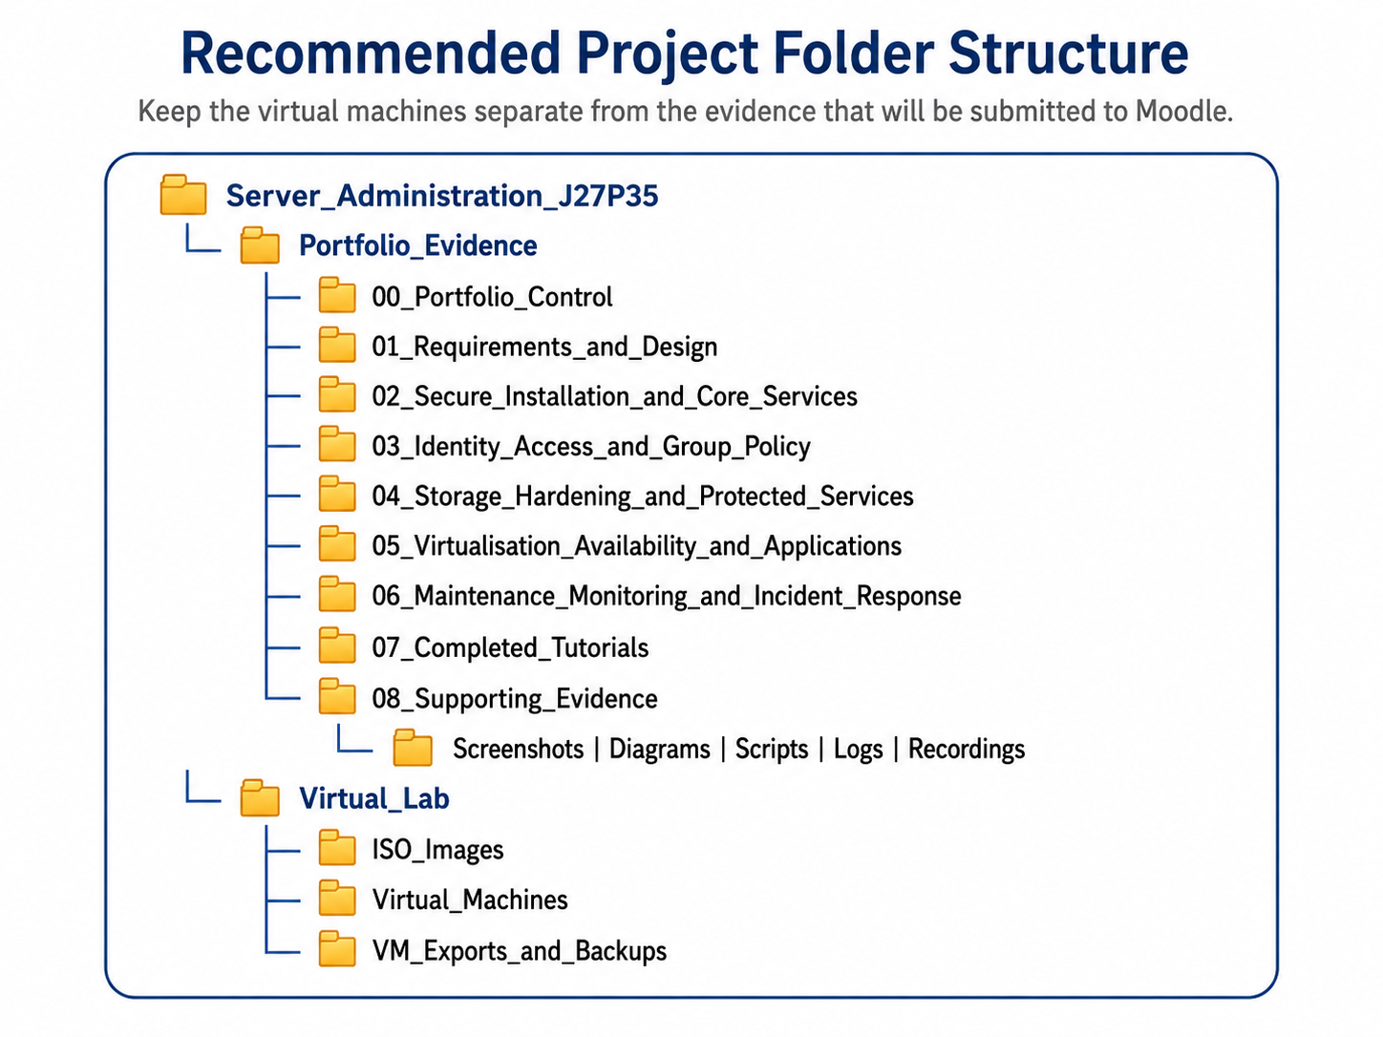
Figure 1. Recommended project folder structure.

4.1 Create the folders
- Open File Explorer and browse to your approved storage location.
- Create the top-level folder Server_Administration_J27P35.
- Inside it, create Portfolio_Evidence and Virtual_Lab.
- Inside Portfolio_Evidence, create the numbered folders shown in Figure 1. The numbering keeps the folders in the same order as the master portfolio sections.
- Inside 08_Supporting_Evidence, create subfolders named Screenshots, Diagrams, Scripts, Logs and Recordings.
- Inside Virtual_Lab, create ISO_Images, Virtual_Machines and VM_Exports_and_Backups.
- Copy only lecturer-approved ISO files into ISO_Images. Do not rename an ISO unless your lecturer instructs you to do so.

4.2 Apply a clear evidence naming standard
Use filenames that identify the week, system and purpose. Avoid names such as image1.png, screenshot-final-final.png or test.docx.
Evidence type | Poor filename | Improved filename
Screenshot | Screenshot1.png | W01_VMware_Lab_Structure.png
Diagram | diagram.png | W01_Freeman_Lab_Overview.png
Weekly tutorial upload | week1.docx | Surname_Firstname_Week_01.docx

Evidence capture point
Capture one screenshot showing the full folder structure in File Explorer. Make sure the folder names are readable. Do not include unrelated personal folders or filenames in the image.

4.3 Record the secure storage plan
Write a short storage plan of approximately 100 to 150 words. It should explain:
- where the working portfolio and supporting evidence will be stored;
- who should be able to access the files;
- how accidental loss will be reduced through approved backup or version history;
- how passwords, private keys, recovery keys and personal data will be excluded;
- how obsolete or duplicate files will be controlled so that the submitted version is clear.
Draft storage plan:

5. Task 2 - Prepare VMware Workstation Pro
The VMware interface may vary slightly between versions, but the main workflow remains the same. This tutorial uses VMware Workstation Pro on a Windows host.
- Open VMware Workstation Pro.
- Do not open or modify virtual machines belonging to another learner.
- Confirm that the default VMware networks are visible. VMnet1 is normally host-only and VMnet8 is normally NAT. You will create a separate host-only network for Freeman Industries so that the lab is clearly identified and isolated.

5.1 Create the isolated Freeman Industries network
- From the VMware menu, select Edit and then Virtual Network Editor.
- Select Change Settings if the editor asks for administrative approval. On a managed college computer, your lecturer may need to complete this step.
- Select Add Network and choose an unused network such as VMnet2. The exact available number may be different on your computer.
- Set the network type to Host-only.
- Set the subnet IP to 10.10.10.0 and the subnet mask to 255.255.255.0.
- Clear the option Use local DHCP service to distribute IP address to VMs. Static addressing and DHCP will be configured deliberately in later weeks.
- Leave Connect a host virtual adapter to this network enabled unless your lecturer instructs you otherwise. This allows the host to communicate with the isolated lab for management and troubleshooting.
- Apply the settings and close the Virtual Network Editor.
Why host-only?
A host-only network creates a private LAN shared by the host and the virtual machines connected to that VMware network. Other computers on the physical network cannot directly communicate with the lab. This is suitable for an isolated teaching environment.

5.2 Keep NAT available only for controlled internet access
VMnet8 normally provides NAT access through the host. Leave the default NAT network available, but do not connect all lab machines to it permanently. Later, when updates are required, your lecturer may authorise a temporary second network adapter or a temporary change to NAT. Remove or disconnect that access after the authorised activity.
Do not use Bridged networking
Bridged networking places the virtual machine onto the same physical network as the host. That is not appropriate for this lab unless a lecturer has explicitly designed and authorised the activity.

Evidence capture point
Capture the Virtual Network Editor showing the selected host-only VMnet, subnet 10.10.10.0/24 and VMware DHCP disabled. Do not expose unrelated network details if they are not required.

6. Task 3 - Plan the Week 1 virtual lab
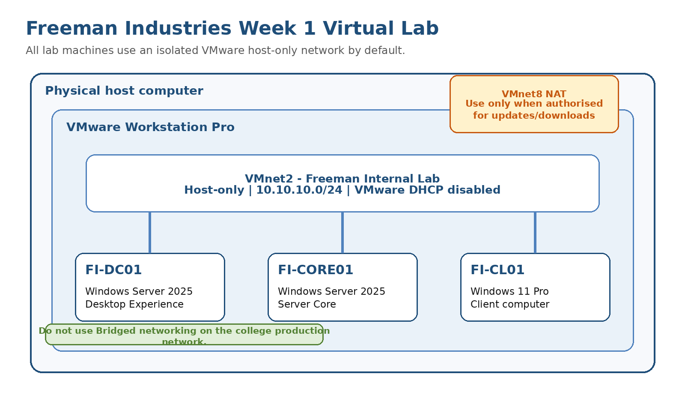
Figure 2. Initial VMware lab structure. Additional servers and services will be introduced later.
Create three empty virtual-machine shells. The operating systems will be installed in a later tutorial. The practical lab is smaller than the full business design, which is permitted when hardware is limited, provided that later design work explains how the full requirement would be met.
VM name | Planned purpose | Guest OS | Suggested starting resources
FI-DC01 | Future first domain controller and DNS server | Windows Server 2025 Desktop Experience | 1 processor, 2 cores; 4 GB RAM; 80 GB disk
FI-CORE01 | Server Core practice and future member-server role | Windows Server 2025 Server Core | 1 processor, 2 cores; 2-3 GB RAM; 60 GB disk
FI-CL01 | Client testing, domain join and Group Policy validation | Windows 11 Pro | 1 processor, 2 cores; 4 GB RAM; 64 GB disk

Resource adjustment
The figures above are starting values, not mandatory hardware specifications. You can adjust as necessary. Do not run every VM at the same time if the host does not have enough memory.

7. Task 4 - Create the virtual-machine shells
Complete the following process for FI-DC01, FI-CORE01 and FI-CL01. Do not install an operating system yet.

7.1 Start the New Virtual Machine Wizard
- Select File > New Virtual Machine, or select Create a New Virtual Machine from the Home screen.
- Choose Custom if available. Custom mode gives you direct control over the network, firmware and virtual hardware.
- Accept the newest hardware compatibility supported by the computers used in the class unless it requires compatibility with an older version.
- At the installation-media screen, select I will install the operating system later. This prevents an unattended installation from beginning before you have recorded the planned settings.

7.2 Select the guest operating system
- For FI-DC01 and FI-CORE01, select Microsoft Windows and Windows Server 2025 x64 if it is listed.
- If Windows Server 2025 is not listed, select Windows Server 2022 x64 as the nearest profile. This choice controls VMware defaults; it does not change the operating system that will later be installed from the approved Windows Server 2025 ISO.
- For FI-CL01, select Microsoft Windows and Windows 11 x64.

7.3 Name and locate the virtual machine
1. Enter the exact VM name from the table in Section 6.
2. Store the VM inside Virtual_Lab\Virtual_Machines\<VM name>. Each VM must have its own subfolder.
3. Do not store the VM inside the Portfolio_Evidence folder. Virtual disks are too large for the weekly Moodle submission and should not be treated as portfolio evidence.

7.4 Configure firmware and processors
1. Use UEFI firmware where the wizard offers the choice.
2. Configure one virtual processor with two cores. This gives the guest two virtual CPU cores without creating multiple virtual processor sockets.
3. Do not enable nested virtualisation unless a later tutorial specifically requires it.

7.5 Configure memory
- Set the initial memory according to the VM table in Section 6 or the value supplied by your lecturer.
- Check the total memory planned for all running VMs. Keep enough memory free for Windows and VMware Workstation on the host.

7.6 Connect the VM to the isolated network
- Select Use network address translation, host-only or custom depending on the wizard screen, then choose Custom: Specific virtual network.
- Select the host-only VMnet created in Section 5, such as VMnet2.
- Do not select Bridged.

7.7 Create the virtual disk
- Accept the recommended virtual disk controller unless your lecturer specifies an alternative.
- Create a new virtual disk using the size shown in Section 6.
- Do not allocate all disk space now. A growable virtual disk uses host storage as data is added.
- Splitting the virtual disk into multiple files is acceptable and can make moving the VM easier. Use the same choice consistently across the class.
- Store the VMDK file inside the VM's own folder.

7.8 Review and finish
- Review the summary before selecting Finish.
- Open Edit virtual machine settings and confirm the following: correct memory, two virtual CPU cores, one network adapter connected to the Freeman host-only VMnet, and the expected disk size.
- Remove unnecessary devices only if instructed. Do not add a virtual TPM at this stage unless your lecturer has explained how VM encryption and recovery keys will be managed.
- Repeat the process for the other two VMs.

7.9 Complete the VM configuration record
Setting | FI-DC01 | FI-CORE01 | FI-CL01
VM folder path | [Enter] | [Enter] | [Enter]
Guest OS profile | [Enter] | [Enter] | [Enter]
Firmware | [Enter] | [Enter] | [Enter]
CPU allocation | [Enter] | [Enter] | [Enter]
Memory | [Enter] | [Enter] | [Enter]
Disk size | [Enter] | [Enter] | [Enter]
VMware network | [Enter] | [Enter] | [Enter]
Operating system installed? | No | No | No

Evidence capture point
Capture either one clear screenshot of the VMware Library showing all three VMs or three screenshots showing each VM name and its hardware summary. The network adapter should be shown as connected to the isolated VMnet. Explain what each image proves.

8. Task 5 - Apply an initial security baseline to the VM shells
Although the operating systems are not installed yet, several choices reduce avoidable risk and confusion.
- Use consistent VM and folder names. Names should not contain a password, username or other secret.
- Connect each VM only to the approved host-only VMware network by default.
- Do not enable shared folders between the host and guests unless a later task requires them and the security implications have been considered.
- Do not attach unknown ISO files, downloaded appliances or virtual disks.
- Keep the virtual-machine folder separate from portfolio evidence and do not submit VMDK files to Moodle.
- Do not create unnecessary snapshots. Snapshots are not a replacement for a tested backup or export.
- Record any deviation from the class standard and explain why it was necessary.

9. Task 6 - Test and verify the Week 1 setup
Testing proves that the structure has been created as intended. Complete the table using the expected and actual results. Do not mark a test as passed until you have checked it.
No. | Test | Expected result | Actual result | Pass / Fail
1 | Open every portfolio and lab folder. | Every folder opens and is clearly named. | [Enter result] | [Pass / Fail]
2 | Check the VMware Library. | FI-DC01, FI-CORE01 and FI-CL01 are listed. | [Enter result] | [Pass / Fail]
3 | Inspect each VM network adapter. | Every VM uses the approved host-only VMnet. | [Enter result] | [Pass / Fail]
4 | Review the Virtual Network Editor. | The Freeman VMnet is host-only and VMware DHCP is disabled. | [Enter result] | [Pass / Fail]
5 | Review evidence files. | No passwords, keys, private data or unrelated personal information are visible. | [Enter result] | [Pass / Fail]
6 | Check filenames. | Evidence filenames identify the week and purpose. | [Enter result] | [Pass / Fail]

9.1 Optional isolation check
Because the operating systems have not been installed, you cannot yet run IP connectivity tests inside the guests. You can still verify isolation by confirming that no VM uses Bridged and that the isolated VMnet does not use VMware DHCP. Network connectivity tests will be performed after the operating systems are installed and addressed.

10. Task 7 - Begin the Freeman Industries requirements register
Read the Scenario Brief and Assessment Brief. Identify at least five business or security requirements. A requirement should state what the new infrastructure must achieve. Avoid copying a problem without translating it into a requirement.
Worked example
Scenario problem: Most computers use local accounts and inconsistent password settings.
Derived requirement: Freeman Industries requires central identity and authentication so that accounts and password controls can be managed consistently and audited.
Security reason: Central management improves accountability, supports account lifecycle control and reduces inconsistent local configuration.

Ref | Scenario evidence or problem | Derived requirement | Why it matters
W01-R01 | [Enter] | [Enter] | [Enter]
W01-R02 | [Enter] | [Enter] | [Enter]
W01-R03 | [Enter] | [Enter] | [Enter]
W01-R04 | [Enter] | [Enter] | [Enter]
W01-R05 | [Enter] | [Enter] | [Enter]
W01-R06 (optional) | [Enter] | [Enter] | [Enter]

Suitable areas to consider include identity and accounts, network separation, file access, backups and recovery, patching, malware protection, website security, monitoring, documentation, growth and delegated administration. Your requirements should be written in your own words and linked to Freeman Industries.

11. Task 8 - Write the Week 1 security explanation
This tutorial asks: Why is security important when planning a server infrastructure, even before any servers are installed?

Write approximately 150 to 250 words. Your answer should refer to planning decisions such as server placement, network isolation, role separation, account control, evidence protection, recovery and the reduction of attack surface. Relate the explanation to the risks already identified at Freeman Industries.
Draft security explanation:

12. Task 9 - Record a problem and fix
Record one genuine issue encountered during the tutorial. Suitable examples include insufficient disk space, a missing VMnet option, a VM stored in the wrong folder, the wrong guest OS profile, an adapter accidentally set to NAT or Bridged, or unclear evidence filenames.
Stage | What to record
Problem | What did you observe? Include the exact message or incorrect setting where possible.
Investigation | What did you check? Which menu, setting or host resource helped identify the cause?
Cause | What was responsible for the problem?
Correction | What did you change?
Retest | How did you confirm that the final result was correct?

Problem and fix record:

13. Complete This Tutorial and Upload

Uploading the completed Tutorial to Moodle using the following naming convention: Surname_Firstname_Week_01.docx
Before uploading
Open every supporting file, check that it is the final version, and verify that no screenshot or recording contains passwords, private keys, recovery keys, real personal information or unrelated files.

14. Troubleshooting guide
Problem | Likely cause | Action
Virtualisation shows Disabled in Task Manager. | Hardware virtualisation may be disabled or restricted by policy. | Stop and inform the lecturer. Do not change BIOS/UEFI settings without permission.
Virtual Network Editor cannot save changes. | Administrative rights are required. | Ask the lecturer or authorised technician to create the class VMnet.
VMnet2 is already in use. | Another class or application has created it. | Use another unused VMnet number and record the number used.
The required guest OS is not listed. | The installed VMware version has an older profile list. | Select the nearest supported 64-bit profile, such as Windows Server 2022 x64, and record the decision.
The VM was saved in the wrong folder. | The default VMware location was accepted. | Power off the VM, use VMware's move/open workflow or recreate the empty shell in the correct folder. Do not drag a running VM.
The host becomes slow. | Too much RAM or too many VMs are active. | Power off unused VMs and reduce allocations only with lecturer approval.
A VM is connected to Bridged networking. | The default network choice was accepted. | Power off the VM and change its adapter to the approved host-only VMnet.
Moodle file is too large. | Virtual disks or unnecessary media were included. | Submit only the completed tutorial and any approved supporting evidence. Do not upload VM folders, VMDK files or ISO files.

15. Final completion checklist
☐ I created the numbered portfolio evidence folders.
☐ I created separate ISO, virtual-machine and export/backup folders.
☐ I created or confirmed an isolated host-only VMware network.
☐ VMware DHCP is disabled on the Freeman internal VMnet.
☐ No lab VM is connected to Bridged networking.
☐ FI-DC01, FI-CORE01 and FI-CL01 appear in the VMware Library.
☐ Each VM is stored in its own folder and uses the approved internal VMnet.
☐ I completed at least five Freeman Industries requirements.
☐ I wrote a secure evidence storage plan.
☐ I completed and recorded the Week 1 tests.
☐ I explained each screenshot or diagram in my own words.
☐ I removed or hid passwords, keys and personal information.
☐ I can demonstrate the folder and VMware configuration if asked.

16. Short reflection
Which Week 1 planning decision is most important for keeping the practical lab safe, and why?

What would be the main risk of storing virtual machines, passwords and portfolio evidence together in one uncontrolled folder?

